УДК 621.793.6
6
DOI 10.36910/10.36910/6775-2313-5352-2024-24-01

I. Kruhliak, D. Sereda, R. Krivko
Dnipro State Technical University

IMPROVING THE DURABILITY OF THE MECHANICAL EQUIPMENT OF
THE SHAFT BALANCING SYSTEM OF THE 1680 MILL STAND

Current article is a research devoted to an important aspect of improving the durability of mechanical equipment of the shaft balancing system of the working stand of mill 1680, used in the cold rolling process. The paper deals with the methods of reinforcement of machine parts and mechanisms necessary to ensure high reliability and durability of industrial equipment used in metallurgical production. Particular attention is paid to the application of functionally active coatings obtained using the method of self-propagating high-temperature synthesis (SHS) in order to increase wear resistance and reduce energy consumption in operation balancing mechanism. In addition, the article considers the principles of stand operation of rolling mill 1680, including consideration of the features of rolls, supporting rolls, pressure mechanisms and balancing systems, as well as the technology of roll drive and rolling thickness adjustment mechanisms. The final part of the article presents the results of experimental studies on wear resistance of steels with different protective coatings obtained by SHS method, taking into account their microhardness and dependence of wear intensity on the type of alloying, to improve the durability of mechanical equipment.
Key words: production, rolling, durability, self-propagating high-temperature synthesis, pressure mechanism, roller balancing, coating, wear resistance, microhardness.

Problem Statement. The problem statement is to identify the key aspects that need to be addressed in order to improve the durability of mechanical equipment in the conditions of metallurgical production. One of the main challenges is the need to increase the service life of equipment in cold rolling processes, where high mechanical and thermal effects lead to intensive wear. To solve this problem, functional coatings and alloying technologies are actively used to improve the surface characteristics and increase its resistance to wear. However, despite the advances made in this field, it is still unclear which specific factors influence the effectiveness of such coatings and how their application processes can be optimized. It is also important to consider the influence of various manufacturing parameters such as temperature, pressure, speed and material composition on the quality and durability of the coatings. Thus, the main objective is to research and analyze the key factors that determine the performance of functional coatings in a metallurgical manufacturing environment
Analysis of the latest research. Analysis of recent research in the field of functional coatings and alloying technologies to improve the durability of mechanical equipment in metallurgical production allows us to highlight several key directions and results. In recent years, there has been a lot of research devoted to optimizing the composition and structure of functional coatings in order to improve their adhesion, hardness and wear resistance. One of the most promising approaches is the use of alloyed coatings incorporating chromium, silicon and titanium. These materials have high hardness and resistance to abrasive and adhesive wear, making them ideal candidates for metallurgical applications. Considerable attention is also being paid to the study of wear mechanisms and surface-in-contact interactions, allowing for a more accurate determination of factors affecting the durability of coatings. The molecular-mechanical theory of rubbing is widely used to explain the processes occurring during friction and to develop effective methods for reducing wear of surfaces. An important result of research is also the determination of optimal production parameters such as temperature, pressure and speed that maximize the performance of coatings and alloyed materials. This allows optimizing the application processes and improving the quality of the final product. Thus, the analysis of recent research indicates significant progress in the field of functional coatings and alloying technologies for improving the durability of mechanical equipment in metallurgical production, which opens new prospects for the development of this field and improving the efficiency of production processes.
Summary of the main material. Hardening of machine and mechanism parts in industrial engineering for metallurgical production is aimed at ensuring the reliability and durability of rolling mill parts. To improve the reliability of the pressing mechanism of the 1680 continuous cold rolling mill, it is necessary to harden their surface layer, which is obtained with minimal thermokinetic load and increased surface hardness, which directly affects their wear resistance. The wear resistance of the pressure screws was increased by using functionally active blends that provide minimal hardening costs and a significant reduction in energy consumption.
7
The use of SHS for the formation of protective coatings is based on the use of powdered exothermic mixtures where there is a strong exothermic interaction of chemical elements in the condensed phase, which is capable of minimal expansion in the form of a combustion wave. SHS is one of the most high-temperature combustion processes (t = 800-4000 ºC) [1-2]. The essence of the SHS method is to carry out exothermic reactions in the mode of combustion wave propagation with the formation of combustion products in the form of compounds and materials that are of practical value and have valuable characteristics [3]. Such synthesis of materials differs significantly from standard methods of powder metallurgy based on sintering of chemically inert compounds and have a number of obvious advantages, among which we can note the following:
- formation of active chemical and thermal zones, which allows to intensify the transformation of reagents and leads to the formation of desired products;
- use of less expensive chemical energy (heat generation during exothermic reactions) instead of electrical energy to achieve high temperatures required for obtaining products;
- use of relatively simple equipment (instead of furnaces and other heating devices);
- use of rapid layer-by-layer heating of large volumes of reagents instead of slow heating through walls from external heat sources.
From this point of view, SHS processes should find practical application in all cases where there are no raw material or economic constraints. The list of materials in which SHS processes are already playing a significant role includes refractory powders, carbide and boride materials, hard alloys, refractory and building materials, oxide charge and single crystals, phosphors and high-temperature superconductors. Many of these materials are produced on an industrial scale with high technological and economic efficiency [4].
The main working body (tool) of a rolling mill are rolls mounted on roller bearings and support rolls mounted on liquid friction bearings. Very high requirements are imposed on the quality of rolled mill rolls, as they determine the nominal operation of the mill, its productivity and the quality of rolled products produced.
The continuous cold rolling mill 1680 consists of four consecutive quarto working stands. The working stand (fig. 1) consists of two massive cast steel stands made of 35L steel, mounted on plates and fixed with anchor bolts. The stands of the working stand are the most responsible parts of the rolling mill, designed to absorb the forces arising during rolling, and also serve as a connecting element for the installation of all mechanisms of the working stand: working and support rolls with pads, pressure mechanism, flat wire table, the platform of the pressure device and hydraulic device for balancing the upper support and working rolls with pads [5].
Rolls work under conditions of continuous abrasion by metal during rolling, experiencing high dynamic pressures at high metal sliding speeds and varying temperatures. High-quality steels containing a minimum amount of impurities are used for manufacturing of working and supporting rolls. Working rolls of the mill are made of 9Х2MF steel. The surface of the working roll barrel after hardening has a hardness of 90 to 105 Shore units.
Support rolls of the mill are made of composite: axles are made of 40ХН2МА steel, bands are made of 60Х2СMF steel. The hardness of the barrels of support rolls is from 70 to 85 Shore units. Rolls are driven by electric motors through intermediate shafts with gear coupling, gear stand and spindle connection. Rolling speed: working speed up to 10 m/s (maximum), tucking speed up to 0.5m/s [6].
In order for the rolling process to run smoothly, the rolls must occupy a certain position in the working stand. For this purpose, the following mechanisms and devices are provided in each working stand of the continuous wide strip cold rolling mill 1680:
a) vertical positioning of the rolls (pressure mechanisms);
b) balancing of the upper working roll.
The main purpose of the pressure mechanism of the mill is to regulate the thickness of the rolled product, where it is necessary to compensate for its insignificant but rapidly changing deviations. Figure 1 shows the kinematic diagram of the mill.
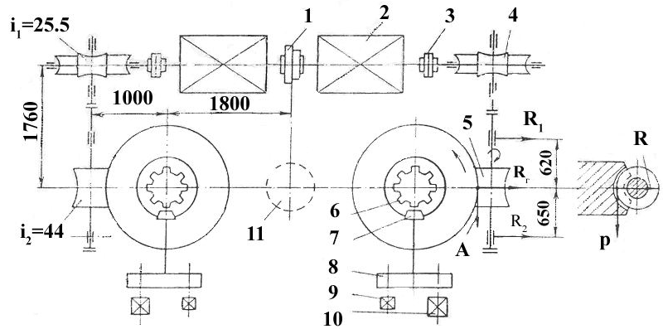
8
Figure 1 – Pressing mechanism of continuous cold strip mill - 1680 [5-7].
1 - electromagnetic clutch, 2 - electric motor, 3 - gear clutch, 4, 5 - worm globoid reducers, 6 - pressure screws, 7 - bevel gear, 8 - kinematic reducer, 9 - selsyn sensors, 10 - command apparatus

The pressure screws of each stand are driven by two electric motors mounted on the same axis and connected by electromagnetic clutch 1, to ensure joint or separate operation of the pressure screws[7]. Power of electric motors 2,46 kW, with a speed of 625 rpm. Rotation from electric motors to pressure screws 6 is transmitted through gear couplings 3 and worm globoid reducers 4, 5. Control of the pressure screws movement is carried out with the help of selsin-sensor 9 (BD-501).
The upper position of the pressure screw is limited by the command device 10, connected to the hub of the worm wheel through the bevel gear 7 and kinematic reducer 8. The distance between the axes of the pressure screws is 2700 mm. The total ratio from the motor to the pressure screw i = 1026. Speed of movement of pressure screws:
a) with a crimping stroke of 8 mm/min;
b) in the reverse stroke, 12.2 mm/min.
The rolling force (P/2) is transmitted from the screw through the nut to the bed and through the latter to the stand foundation. The screws are made of 40X or 40XM steel grades, which, after forging, have a tensile strength of 700-750 MPa. The diameter of the pressure screw is 560 mm, pitch 12 mm. The pressure mechanism gearbox is mounted in a separate housing on top of the frame [8]. If, in one way or another, the top roll cushions were suspended from the ends of the pressure screws, and the top roll was set only by moving the screws up and down, the following negative phenomena would occur:
1) during the idling of the mill under the action of the weight of the top roll and its cushions, gaps would necessarily form between the ends of the pressure screws and their bearings, as well as in the thread of the pressure nut. At the subsequent task of metal into the rolls there would be dynamic loads on the roll journals and on the pressure screws, which would be accompanied by strong shocks;
2) the solution between the rolls would never correspond to the required compression due to the unknown value of the specified gaps.
To avoid these negative phenomena, special devices for balancing the top roll and its cushions are provided in the working stands. With the help of such devices, the cushions of the top roll are always tightly pressed against the faces of the pressure screws and no gaps are formed in the connections between the roll neck and the pressure nut.
Balancing of the upper support and working rolls is performed by means of hydraulic system with oil pressure of 105 atm. Pressure in the hydraulic jack system of the support rolls transfer system is 175 atm.
Protective coatings on 40X steel are widely used in mechanical engineering. Therefore, it is of interest to evaluate the wear resistance of steel after protective boron coatings alloyed with chromium, silicon and titanium have been applied to its surface. The high hardness of these coatings and their ability to retain lubricants on the surface leads to an increase in the wear resistance of these materials. The main objective of the wear resistance study is to determine the most favorable operating conditions for parts hardened by the proposed technology using the developed SHS blends.
The nature and intensity of wear of rubbing surfaces are determined by the conditions in which the product operates and by such characteristics of its working surface as roughness, hardness, presence of a protective coating, etc. In the friction zone of a pair, there are many phenomena of mechanical and physicochemical interaction of materials that determine the nature of wear on their surfaces. These are the processes of strengthening and weakening of the contacting surface areas due to their repeated deformation, heat generation, structure change, oxidation, setting due to micro-welding of irregularities with subsequent erosion, and others. Among the various theories of friction, the molecular-mechanical (or adhesion-deformation) theory stands out, which most fully takes into account the processes occurring during friction [9].
9
Deformation interaction occurs in areas of contact with rough surfaces and causes repeated deformation of the surface layer by irregularities. Mechanical impact can be in the form of elastic or plastic interaction, as well as micro-cutting. Adhesive interaction occurs when micro-weld bridges are formed in the contact zone. Reducing the intensity and even suppressing wear according to molecular mechanical theory helps to: prevent the formation of strong adhesive bonds in friction pores; increase the hardness of friction surfaces. Applying a durable coating to rubbing surfaces can, on the one hand, form a barrier that prevents adhesion of the mating surfaces, and on the other hand, increase the surface hardness. Increasing the hardness of the coated surface, making it difficult to deform plastically and eliminating microneedling, promotes elastic interaction of the rubbing surfaces, which is most favorable for increasing wear resistance. Hence, it is legitimate to assess the performance of a surface with a hardening coating by its hardness (microhardness). The results of testing steel samples for wear under sliding friction conditions on the SMT-1 friction machine are shown in Fig. 2.

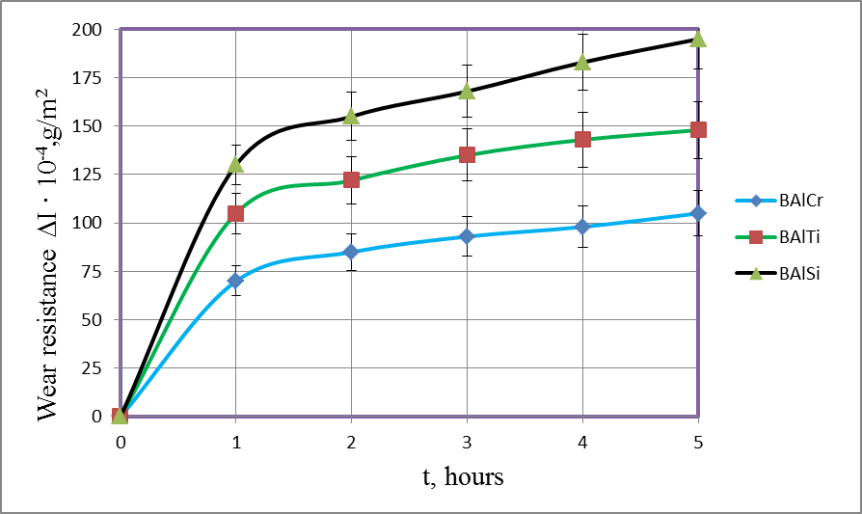
Figure 2 – Wear resistance of coatings on 40X steel obtained under conditions of thermal
self-ignition t_{п}= 1000 °С, τ = 60 min (test on the friction machine SMT-1)

The wear resistance of the alloyed coatings obtained during testing on the SMT-1 friction machine was determined to depend on the type of alloying, which is described by a fifth-order polynomial depending on the test time. It is proved that the best indicators of wear resistance under sliding friction conditions are protective coatings alloyed with chromium and titanium. Thus, in tests on the SMT-1 machine, protective coatings alloyed with chromium and titanium have a wear value of ΔI = 105-148 ·10⁻⁴ g/m². Their wear resistance is 1.2-1.3 times higher than that of protective coatings obtained under isothermal conditions, which is explained by their higher microhardness values. Thus, the microhardness for coatings obtained under isothermal conditions with titanium alloying H₁₀₀ = 18600 MPa, with silicon alloying H₁₀₀ = 17800 MPa, with chromium alloying H₁₀₀ = 18200 MPa.
Conclusions. After conducting research, it was found that the use of SHS-synthesis-based functional-active charges contributes to a significant increase in the wear resistance of parts of the shaft balancing system of the working stand of the 1680 mill. This important discovery reflects the prospects for the metallurgical industry, offering effective methods to reduce energy costs and increase the durability of equipment. In tests on the SMT-1 machine, protective coatings alloyed with chromium and titanium have a wear value of ΔI = 105-148 ⁻¹⁰⁻⁴ g/m². Their wear resistance is 1.2-1.3 times higher than that of protective coatings obtained under isothermal conditions, which is explained by their higher microhardness values. Thus, the microhardness for coatings obtained under isothermal conditions with titanium alloying H₁₀₀ = 18600 MPa, with chromium alloying H₁₀₀ = 18200 MPa. Thus, the research results not only confirm the effectiveness of the application of these coatings, but also have broad practical and scientific implications, including the improvement of production processes and competitiveness of enterprises in the metallurgical industry.
10

References
- Трефілова Н.В. Аналіз сучасних методів нанесення захисних покриттів // Сучасні наукомісткі технології. 2014. № 10. С. 67–67.
- Середа Б.П., Банніков Л.П.,. Нестеренко С.В, Кругляк І.В.,. Гайдаєнко О.С, Середа Д.Б. Поверхневе зміцнення матеріалів працюючих в умовах комплексного впливу агресивних речовин: монографія. Кам'янське: Дніпровський державний технічний університет, 2019. 170с.
- Sereda B. High-performance chrome coatings to protect against wear and corrosion Steel Properties and Applications in Conjunction with Materials Science and Technology 2021, P. 39–41.
- Савуляк В.І. Наплавлення високовуглецевих зносостійких покриттів/ Савуляк В. І., Шенфельд В.Й..// Монографія. Вінниця: ВНТУ. 2016. 124с.
- Прищип М.Г. Обладнання прокатних цехів Навчальний посібник для студентів ЗДІА металургійних спеціальностей денної та заочної форми навчання / Запоріжжя: ЗДІА, 2016. 116с.
- Середа Б.П. Обробка металів тиском. Навч. посіб. для студ. ВНЗ / Запорізька держ. інженерна академія. Запоріжжя : [Видавництво Запорізької держ. інж. акад.], 2009. 342 с. Бібліогр.: с. 342. ISBN 978-966-8462-11-5
- Данченко В.М. Обробка металів тиском : навч. посіб. для студ. вищ. навч. закл. за напрямком "Металургія". 2006. 183 с.
- Середа Б.П. Прокатне виробництво: навч. посіб. для студ. ВНЗ / Запорізька держ. інженерна академія. Запоріжжя : Вид-во Запоріэької держ. інж. акад. 2008. 310c.
- Cheiliakh, O.P., Ryabikina, M. A., & Kutsomelia, Y. Y. (2015). Моделювання впливу параметрів дифузійного хромування на експлуатаційні та фізико-механічні властивості сталей для штампового інструменту. Вісник Приазовського Державного Технічного Університету. Серія: Технічні науки, (29), 56–64.

Ірина Кругляк, Дмитро Середа, Руслан Кривко
Дніпровський державний технічний університет

ПІдвищення довговічності механічного обладнання системи урівноваження валів робочої кліті СТАНУ 1680

Дослідженням, присвяченим важливому аспекту підвищення довговічності механічного обладнання системи врівноваження валів робочої кліті стану 1680, використовуваного в процесі холодної прокатки. У роботі розглядаються методи посилення деталей машин і механізмів, необхідних для забезпечення високої надійності та довговічності промислового обладнання, що застосовується в металургійному виробництві. Особлива увага приділяється застосуванню функціонально-активних покриттів, одержуваних з використанням методу саморозповсюджувального високотемпературного синтезу (СВС), з метою підвищення зносостійкості та зниження енерговитрат при експлуатації врівноважуючого механізму. Крім того, у статті представлено докладні описи конструкції та принципів роботи робочої кліті прокатного стану 1680, включно з розглядом особливостей валків, опорних валків, натискних механізмів і систем врівноваження, а також технології приводу валків і механізмів регулювання товщини прокату. У заключній частині статті представлено результати експериментальних досліджень щодо зносостійкості сталей з різними захисними покриттями, отриманими методом SHS, з урахуванням їхньої мікротвердості та залежності інтенсивності зносу від типу легування, що робить роботу актуальною та корисною для практичного застосування в індустріальній сфері.
Ключові слова: виробництво, прокатка, довговічність, саморозповсюджувальний високотемпературний синтез, натискний механізм, врівноваження валків, покриття, зносостійкість, мікротвердість.

