УДК 621.9.06

UDC 621.9.06

R. Polinkevich, N. Zubovetska, R. Redko, T. Chetverzhuk, O. Zaleta, B. Valetskyi, М. Pylypets

Lutsk National Technical University

RESEARCH OF TEMPERATURE PROCESSES DURING DRILLING OF HOLES

The paper addresses an axisymmetric thermophysical problem occurring during deep-hole drilling, based on a proposed mathematical model for temperature calculation using the heat source method and the principles of spatial-temporal correspondence and local influence. The dependencies of the thermal process were determined, taking into account the mutual positioning of the cutting tool and the part, the material of the workpiece, the presence of cooling with cutting fluid, cutting conditions, chip removal, and the duration of the drilling operation itself. This is particularly important for deep drilling, where the heat source is continuously displaced.
It was established that the calculation of the temperature field in the workpiece depends on the action of a ring-shaped heat source with a uniform heat release intensity distribution. Theoretical analysis showed that the maximum temperature should not exceed 300 °C (without lubricating and cooling fluid) and 180 °C (with lubricating and cooling fluid), respectively. Standard chromel-alumel thermocouples (temperature range −100 °C to +1000 °C) were used for temperature measurement.
Deep-hole drilling experiments were performed on parts made of Steel 45 (analogous to C45E and Ck45 according to the EU standard EN 10083-2) with diameters of 10 mm and 20 mm, using special deep-drilling tools. The machining was carried out on a universal lathe model 16K20, modified for deep drilling. The temperature in the tool-workpiece contact zone and the temperature distribution within the workpiece (temperature gradient) were calculated. The adequacy of the proposed mathematical model was confirmed, as the calculated temperature values corresponded well with the experimental data.
Keywords: heat source, deep drilling, thermal conductivity, heat source method, principle of spatial-temporal correspondence.

INTRODUCTION
Parts with deep holes are manufactured across all areas of mechanical engineering and instrument making. Deep holes are primarily associated with moving parts of machines and mechanisms, determining their performance characteristics, reliability, and operational durability.
A hole is considered deep if the ratio of its length to diameter exceeds 10. However, in practice, when machining a hole to a depth greater than three diameters, difficulties arise with chip removal, reduced drill stability, and decreased machining productivity.
Deep-hole drilling technologies differ from conventional hole machining and require the use of specialized equipment and technological tools ‒ namely special cutting, auxiliary, measuring tools and devices. During deep drilling, a lubricating and cooling fluid (LCF) is supplied to the tool, which defines not only the specific features of the process but also those of the equipment and tools used [1].
When drilling holes, an axisymmetric thermophysical problem arises, associated with calculating the temperature field of the workpiece from the action of a heat source in the form of a ring with a uniform distribution of heat release intensity.
ANALYSIS OF LITERATURE DATA AND STATEMENT OF THE PROBLEM
Representation of the thermal process makes it possible to use the fundamental solution of the heat conduction equation for axisymmetric thermophysical problems, for example, the expression for calculating the temperature field in an infinite body with an instantaneous source of power q, J/m in the form of a circle with radius r', acting in the plane z'=0 at time t=0 [2]:

$θ\left(r,z,t\right)=\frac{Q}{8cρ{\left(πat\right)}^{\frac{3}{2}}}exp\left[-\frac{r^{2}+{\left(r'\right)}^{2}+{\left(z-z'\right)}^{2}}{4at}\right]I_{0}\left(\frac{rr'}{2at}\right)$, (1)

where Q=2πrʹq; $I_{0}\left(\frac{rr'}{2at}\right)$ – Bessel function of zero order from the imaginary argument;
$a=\frac{λ}{Cp}$ – thermal conductivity coefficient; Cρ – volumetric heat capacity; λ – thermal conductivity coefficient.
According to the method of images, the thermal regime in a body with an opening of radius r₀, on the adiabatic surface of which an annular heat source with power Q = 2πr₀ q is located, will be equivalent to the thermal regime in an infinite body in the region r ≥ r₀, if, in the latter, a ring source of double power Q₀=2Q is placed at r = r₀ , and a heat sink with power Qс = -Q is placed at r = 0.
In the adopted schematisation of the thermal regime, heat transfer to the environment, the workpiece and the tool is not taken into account, since these heat exchange conditions can be taken into account through the corresponding coefficient when solving the balance problem. During drilling, about 75% of the heat is transferred to the workpiece.
According to the principle of local influence [3], it is permissible to consider the temperature field in the part as the sum of two components: the general field, located far from the source, and the local field, directly in the source space. In this case, when determining the general field, the heat source may be schematized in various ways, while more accurate heat dissipation conditions should be taken into account. When calculating the local field, the heat dissipation conditions may be simplified, but the intensity distribution of the local source must be represented as accurately as possible.
In this regard, when calculating the local temperature field in a part, the following simplification can be made. The workpiece can be conditionally represented as an unlimited body with a cylindrical hole of radius r₀. Further, considering that the circumferential speed of the source is several orders of magnitude greater than the feed rate, according to the Peclet criterion $e=\frac{2VR}{a}≥10$ , such a fast-moving local source can, within one revolution of the part, be regarded as an instantaneous spatial ring [4] with an intensity distribution along the radial direction r and coordinate z following to the normal Gaussian law:

$q\left(r^{'},z'\right)=q_{0}exp\left[-k\frac{{\left(r_{0}-r'\right)}^{2}+{\left(z'\right)}^{2}}{R^{2}}\right]$. (2)

According to the principle of space-time correspondence [5], to transition from the solution describing the temperature field in an infinite body with an instantaneous ring source (1) to the corresponding solution with a normal toroidal source (2), it is sufficient to introduce a time constant:

$t_{0}=\frac{R^{2}}{4ak}$,

where R is the characteristic size of the heat source m; k is the concentration coefficient of the source intensity.
PURPOSE AND TASKS OF THE RESEARCH
The purpose of this work is to experimentally investigate the temperature factors in the tool-workpiece contact zone. The objective is to develop a mathematical model for heat accumulation in the cutting zone during deep hole drilling and to verify its adequacy.
RESEARCH RESULTS
It is known that for small time intervals, i.e., for large values of the Bessel function argument, in relations (1) the following substitution can be made:

$I_{0}\left[\frac{rr'}{2at}\right]≈\frac{exp\left[\frac{rr'}{2at}\right]}{\sqrt{2π\frac{rr'}{2at}}}$.

After the transformations for small time intervals, the solution describing the thermal regime in an infinite body with an opening of radius r₀ with a normal toroidal source, at r' = r₀, z' = 0, is obtained in the following form:

$θ\left(r,z,t\right)=\frac{Q}{8λπ^{2}\sqrt{rr_{0}}\left(t+\frac{R^{2}}{4ak}\right)}exp\left[-\frac{{\left(r-r_{0}\right)}^{2}+z^{2}}{4a\left(t+\frac{R^{2}}{4ak}\right)}\right]$. (3)

If the local field takes into account the process of heating the part over a time interval corresponding to one revolution of the source, then the total field must take into account the accumulation of heat over the entire processing time, as well as for the additional heating caused by it.
In accordance with the principle of local influence, it is reasonable to assume that each individual revolution of the source preceding the last one, which determines the local field, represents an instantaneous heat impulse maximally concentrated along the radial and generatrix directions. Based on this, the process of heat accumulation in the body can be represented by the following diagram.
Let us assume that the heat source J₀ (Fig. 1), which determines the local field in the area near the diametral cross-section z=0, appears at time t=0. Accordingly, the previous revolution of the source, rotating with an angular velocity ω and having a feed rate S per revolution (shown in the diagram as the instantaneous ring source J₁), ended before the moment of time t₁=2π/ω, at a distance z₁=S from the source J₀.

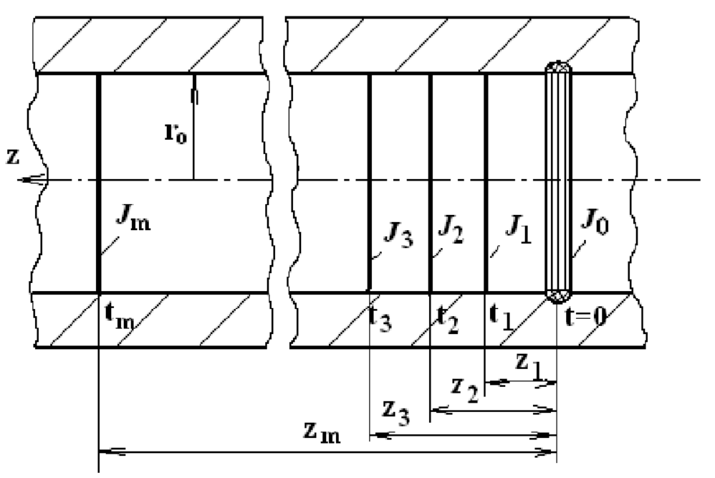

Figure 1 – Diagram for calculating heat accumulation in a body with an opening

Even earlier, at time t₂ = 2t₁ 1and at a distance z₂=2z₁, the ring source J₂ was active, and so on, until the first instantaneous ring pulse J_{m} occurred at time t_{m}=2πm/ω at position z_{m}=mS. According to the adopted scheme, the accumulation of heat in the part can be represented as an increase in the temperature of the local field due to the contribution of each instantaneous ring source, i.e.,

$θ_{0}=\sum_{i=1}^{m}{θ_{i}\left(J_{i}\right)}$.

Since the increase in the temperature of the local field from each source is determined over a relatively short period of time, the temperature of the general field can be calculated using relation (3). By setting r=r₀, t_{i}=2πm/ω, and z_{i}=mS, we obtain the following expression:

$θ_{0}\frac{Q}{16π^{3}λr_{0}}\sum_{i=1}^{m}{\frac{ω}{m_{i}}exp\left[-\frac{ωS^{2}}{8πa}∙m_{i}\right]}$. (4)

The effect of heat flow, which is taken into account when modelling the process in an infinite body, can be considered using relation (1). In this case, we should set rʹ=0, r=r₀, z=z_{i}, t=t_{i}, and I₀(0)=1. As a result, it follows that the decrease in the temperature of the local field over m revolutions of the heat source (t₁=2πm/ω, z_{i}=mS) is determined by the following relation:

$θ_{c}=\frac{-Q_{c}}{8cρ{\left(πa\right)}^{\frac{3}{2}}}\sum_{i=1}^{m}{{\left(\frac{ω}{2πm_{i}}\right)}^{\frac{3}{2}}}exp\left[-ω\frac{r_{0}^{2}+{\left(Sm_{i}\right)}^{2}}{8πam_{i}}\right]$ (5)
Thus, in accordance with the imaging technique for a body internally bounded by an opening, the local field in the region affected by a normal toroidal source is calculated using formula (3); the increase in the temperature of the local field due to heat accumulation is determined by the ratio of the total temperature field (4), while the decrease in the temperature of the local field caused by heat flow for each of the m_{i} ring sources is calculated using formula (5).
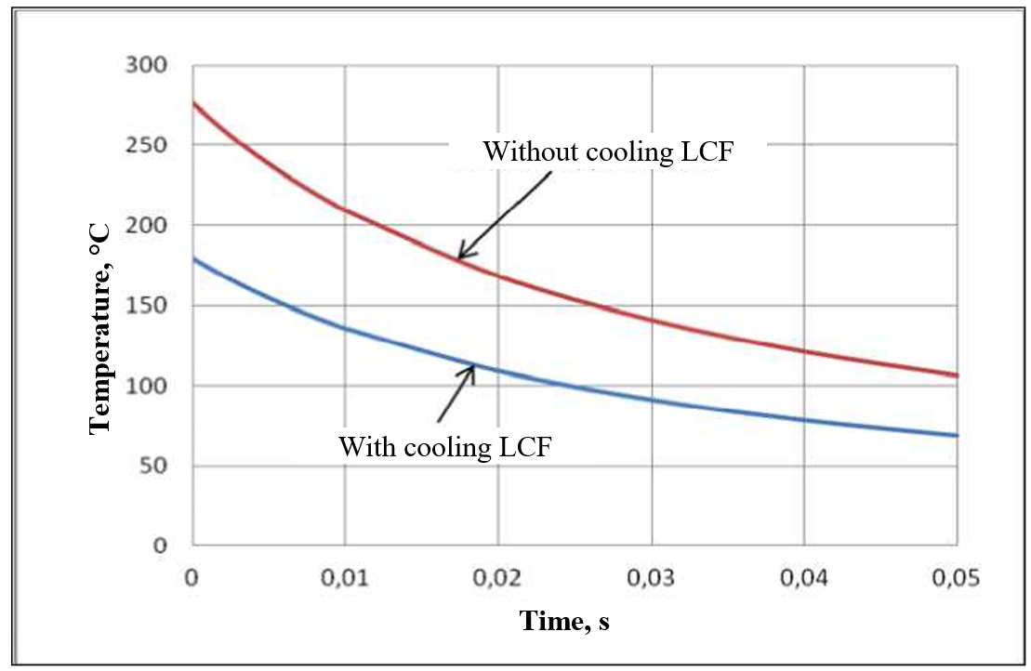

Figure 2 – Dependence of the temperature on the surface of the hole on time during drilling of steel 45

( λ=60 $\frac{W}{m∙℃}$; а=0,08·10⁻⁴ $\frac{m^{2}}{s}$; ср=5,02·10⁶$\frac{J}{m^{2}∙℃}$; R=2,5·10⁻³ m;
Р₀=2174 Н; k=2π; z=0)

Fig. 3 and Fig. 4 show the level of heat accumulation in the part and the effect of heat flow for the following process parameters: r₀=0,01 m; V = 25 m/s; S = 0.25 mm/rev during the processing of steel 45.
As the calculations show, a slight increase in the local field temperature is influenced by slightly more than 6 revolutions of the source (Fig. 3). As can be seen from Fig. 4, concentrated heat flow does not affect the machining of a 10 mm diameter hole; the effect appears when r₀ < 5mm.

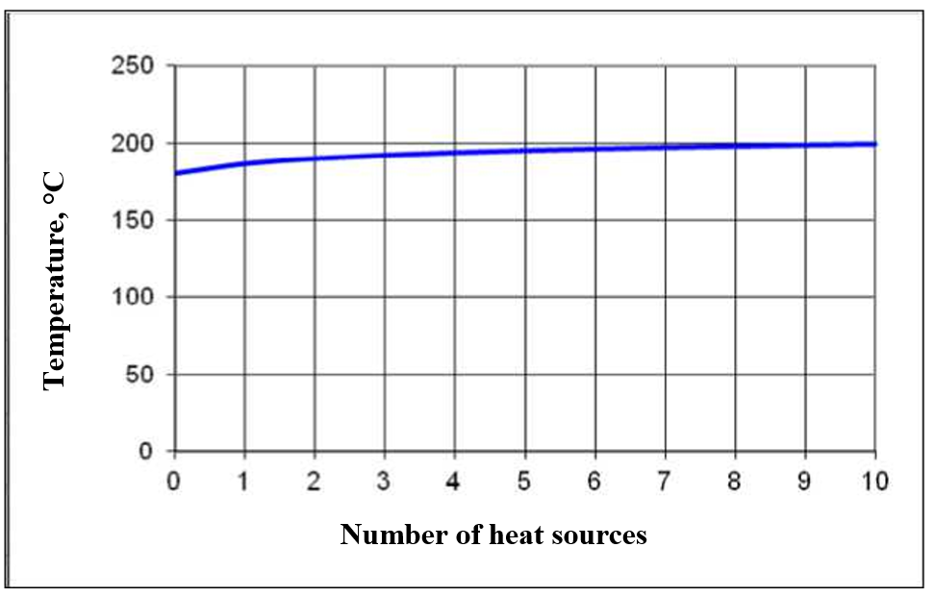

Figure 3 – Effect of heat accumulation on the surface temperature of the hole
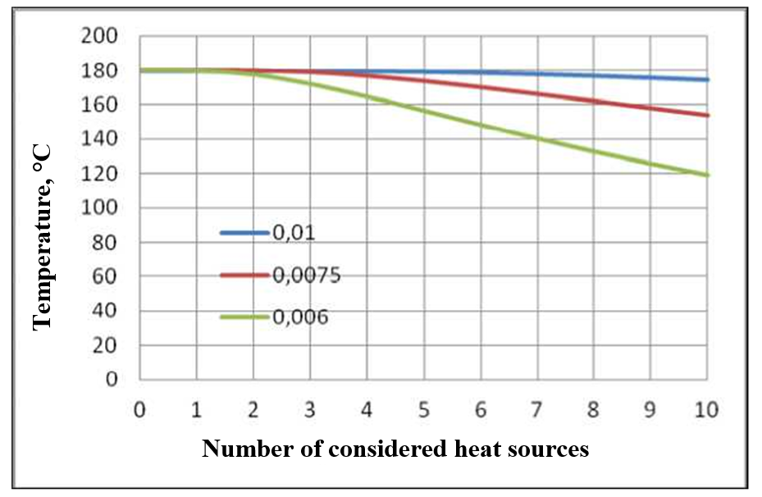

Figure 4 – Effect of heat flow on the temperature at the centre of a normal toroidal source depending on the radius of the ring source (r₀=0.01 m, r₀=0.005 m, r₀=0.004 m)

As part of the scientific work, deep holes with diameters of 10 and 20 mm were drilled using special deep drilling bits. The processing was carried out on a universal lathe model 16K20, which was modernised for deep drilling. During drilling, an experimental study was conducted on the temperature in the tool-workpiece contact zone, as well as the heat distribution in the workpiece, since, according to [6, 7], during drilling, about 75% of the heat is transferred to the workpiece.
The features of various methods of experimental study of thermal phenomena (the pyrometric method [8], the method of artificial and natural thermocouples, the method of heat-sensitive paints, the method of melting pure metals, and others [9, 10]) were analysed, and it was proposed to measure the temperature using the artificial thermocouple method.

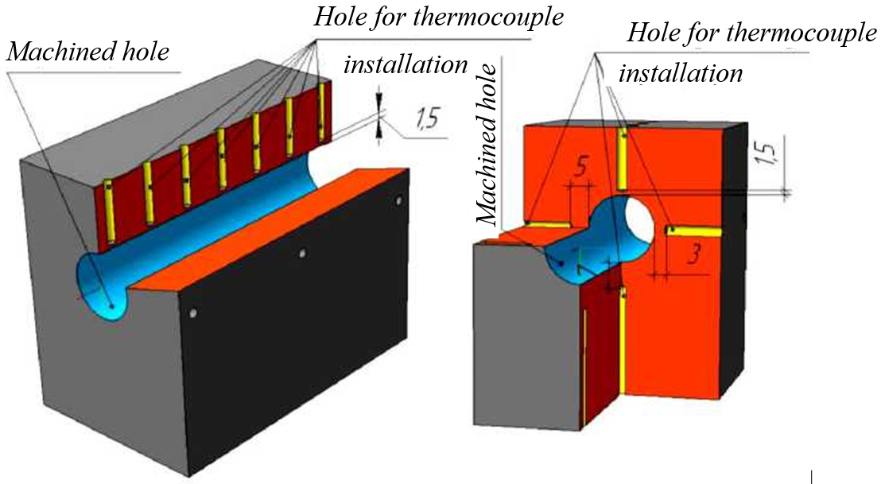

Figure 5 – Layout of channels for installing thermocouples in the workpiece

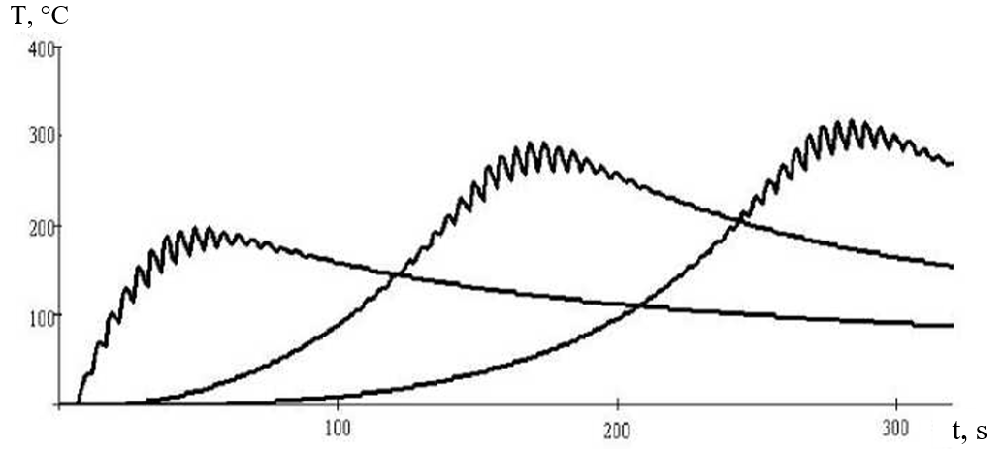

Figure 6 – Temperature change graphs for points located at different distances from the end of the workpiece

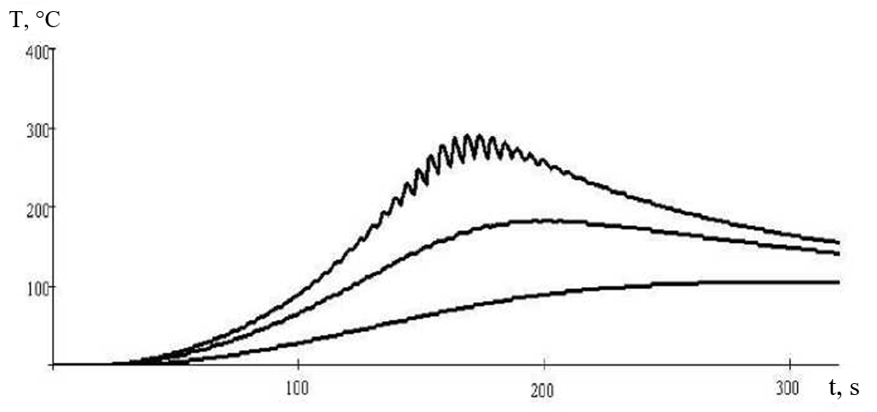

Figure 7 – Temperature change graphs for points located at different depths from the surface of the hole

Since theoretical research has shown that the maximum temperature should not exceed 300 °C (without CLF cooling) and 180 °C (with CLF cooling), standard chromel-alumel thermocouples were used to measure the temperature. The thermocouples were inserted through holes with a diameter of 2 mm into the processing zone in accordance with the developed scheme (Fig. 5), which made it possible to monitor the temperature variation in the material along the axis of the hole, as well as in the plane perpendicular to the axis of the hole. The temperature in the tool-part contact zone could then be theoretically determined based on the experimentally obtained temperature gradient (Fig. 6 and Fig. 7).

CONCLUSIONS
The method of imaging an axisymmetric temperature field in a body internally bounded by a cylindrical hole as an adequate thermal regime in an unbounded body using fictitious (reflected) heat sources has been substantiated.
It is shown that the thermal regime in a body with an opening that arose during mechanical processing can be conditionally divided into local and general temperature fields, with the local field determining the temperature directly in the area of action of the local source, and the general temperature field determining the increase in the thermal stress of the local field due to the accumulation of heat in the processed part.
The adequacy of the proposed mathematical model has been experimentally verified.

REFERENCES
1. Bogdanov, O. O., Derbaba, V. A., Dubrovsky, S. S., Ruban, V. M., & Nazarenko, N. S. (2023). Research on cutting temperature during turning of high-hardness cast irons. Collection of scientific papers of NSU, 75(4), P. 44-54. DOI: https://doi.org/10.33271/crpnmu/75.044
2. Cichosz Piotr, Paweł Karolczak, and Kamil Waszczuk (2023). Review of Cutting Temperature Measurement Methods. Materials, 16(19), 6365. DOI: https://doi.org/10.3390/ma16196365
3. Gugnin, V., Perperi, L., Oborskyi, G., Goloborodko, G., Goloborodko, V. (2025). Development of a Simulator Program for Studying the Effect of Cutting Modes on Cutting Temperature. In: Tonkonogyi, V., Ivanov, V., Trojanowska, J., Oborskyi, G. (eds) Advanced Manufacturing Processes VI. Interpartner 2024. Lecture Notes in Mechanical Engineering. Springer, Cham. Pp 279-289. DOI: https://doi.org/10.1007/978-3-031-82746-4_25
4. Kanagaraju, T., et al (2016). Optimization of Drilling Parameters for Thrust Force and Torque in Friction Drilling Process. Middle-East Journal of Scientific Research, 24(4), P. 1577-1582. DOI: 10.5829/idosi.mejsr.2016.24.04.23391
5. Kolesnyk, V.; Peterka, J. et al (2020). Experimental Study of Drilling Temperature, Geometrical Errors and Thermal Expansion of Drill on Hole Accuracy When Drilling CFRP/Ti Alloy Stacks. Material, 13(17), DOI: https://doi.org/10.3390/ma13143232
6. Masahiko Sato, Tomoyuki Aoki, Hisataka Tanaka, Satoshi Takeda (2013). Variation of Temperature at the Bottom Surface of a Hole During Drilling and its Effect on Tool Wear. International Journal of Machine Tools and Manufacture, 68, P. 40-47. DOI: https://doi.org/10.1016/j.ijmachtools.2013.01.007
7. R. Redko et al. (2023). Investigation of Cutting Force During Boring of Screw Non-Rigid Machine Parts. / Modern Technologies in Mechanical Engineering and Transport, 20(1), P. 26-32. DOI: https://doi.org/10.36910/automash.v1i20.1030
8. Stupnytskyy, V.V. (2013). Thermodynamic Pattern of the Workpiece Machining by the Rheological Imitation Modelling in Deform-3D System. Bulletin of the National University of Lviv Polytechnic. Optimization of production processes and technical control in mechanical engineering and instrument making, (772), P. 102-114.
9. Toulouevski, Yuri N., and Ilyaz Y. Zinurov (2013). The Fundamental Laws and Calculating Formulae of Heat Transfer Processes. Innovation in Electric Arc Furnaces: Scientific Basis for Selection. Berlin, Heidelberg: Springer Berlin Heidelberg, P. 33-66.
10. Zubovetska N.T., Redko R.H., Chetverzhuk T.I., et al (2025). Experimental Study of the Process of Boring Machine Parts Using a Cutter Equipped with Tensor Sensors. Scientific bulletin of Ivano-Frankivsk National Technical University of Oil and Gas, 1(58), P. 88-96. DOI: https://doi.org/10.31471/1993-9965-2025-1(58)-88-96

Полінкевич Р., Зубовецька Н., Редько Р., Четвержук Т., Залета О., Валецький Б. Дослідження температурних процесів при свердлінні отворів.
У статті вирішено осесиметричне теплофізичне завдання при свердлінні глибоких отворів на основі запропонованої математичної моделі розрахунку температури за методом джерел тепла з використанням принципів просторово-часової відповідності та місцевого впливу. Визначено залежності теплового процесу, які залежать від взаємного розташування ріжучого інструменту та оброблюваної деталі, матеріалу заготовки, наявності охолодження мастильно-охолоджувальною рідиною, режимів різання, відведенням стружки та часу перебігу самої технологічної операції свердління. Це особливо важливо для глибокого свердління, де джерело тепла постійно зміщується. Встановлено, що розрахунок температурного поля оброблюваної деталі залежить від дії джерела теплоти у формі кільця з рівномірним розподілом інтенсивності тепловиділення.
Теоретичне дослідження показало, що максимальна температура не повинна перевищувати 300 ^{о}С (без охолодження МОР) і 180 ^{о}С (при охолодженні МОР), відповідно для вимірювання температури використовувалися стандартні термопари типу хромель-алюмель (діапазон вимірювання температури від -100 ºС до +1000 ºС).
Експериментально проведено свердління глибоких отворів діаметрами 10 та 20 мм в деталі з матеріалу Сталь 45 (аналоги C45E та Ck45 згідно стандарту Євросоюзу EN 10083-2) спеціальними свердлами для глибокого свердління. Обробка здійснювалася на універсальному токарному верстаті моделі 16К20, модернізованому для глибокого свердління. Розраховано температуру в зоні контакту інструмент-деталь, а також розподіл температури в тілі заготовки (температурний градієнт). Доведено адекватність запропонованої математичної моделі, а розраховані значення температур відповідають отриманим експериментальним даним.
Ключові слова: теплове джерело, глибоке свердління, теплопровідність, метод джерел тепла, принцип просторово-часової відповідності.

ПОЛІНКЕВИЧ Роман Миколайович – кандидат технічних наук, доцент кафедри прикладної механіки та мехатроніки, Луцький національний технічний університет, e-mail: r.polinkevych@lntu.edu.ua. https://orcid.org/0000-0002-4243-5585.
ЗУБОВЕЦЬКА Наталія Тарасівна – кандидат технічних наук, доцент кафедри прикладної механіки та мехатроніки, Луцький національний технічний університет, e-mail: n.zubovetska@lntu.edu.ua, https://orcid.org/0000-0002-3101-3299
РЕДЬКО Ростислав Григорович – кандидат технічних наук, доцент, завідувач кафедри прикладної механіки та мехатроніки, Луцький національний технічний університет, e-mail: redkorg@ukr.net. https://orcid.org/0000-0001-5066-0224.
ЧЕТВЕРЖУК Тарас Іванович – кандидат технічних наук, доцент кафедри прикладної механіки та мехатроніки, Луцький національний технічний університет, e-mail: eti_tar@ukr.net. https://orcid.org/0000-0002-4445-4632.
ЗАЛЕТА Ольга Михайлівна – кандидат технічних наук, доцент кафедри прикладної механіки та мехатроніки, Луцький національний технічний університет, e-mail: olga_zaleta@ukr.net. https://orcid.org/0000-0002-0777-9972.
ВАЛЕЦЬКИЙ Богдан Петрович – кандидат технічних наук, доцент кафедри прикладної механіки та мехатроніки, Луцький національний технічний університет, e-mail: b.valetsky@lntu.edu.ua, https://orcid.org/0000-0002-7704-5253.
ПИЛИПЕЦЬ Михайло Ількович – доктор технічних наук, професор кафедри прикладної механіки та мехатроніки, Луцький національний технічний університет, e-mail: pulupecmi@gmail.com, https://orcid.org/0000-0002-4286-9324

Roman POLINKEVICH ‒ PhD in Engeneering, associate professor of Applied Mechanics and Mechatronics department, Lutsk National Technical University e-mail: r.polinkevych@lntu.edu.ua. https://orcid.org/0000-0002-4243-5585.
Nataliia ZUBOVETSKA – PhD in Engeneering, associate professor of Applied Mechanics and Mechatronics department, Lutsk National Technical University e-mail: n.zubovetska@lntu.edu.ua, https://orcid.org/0000-0002-3101-3299
Rostyslav REDKO ‒ PhD in Engeneering, associate professor, head of Applied Mechanics and Mechatronics department, Lutsk National Technical University e-mail: redkorg@ukr.net. https://orcid.org/0000-0001-5066-0224.
Taras CHETVERZHUK ‒ PhD in Engeneering, associate professor of Applied Mechanics and Mechatronics department, Lutsk National Technical University e-mail: eti_tar@ukr.net. https://orcid.org/0000-0002-4445-4632.
Olha ZALETA ‒ PhD in Engeneering, associate professor of Applied Mechanics and Mechatronics department, Lutsk National Technical University e-mail: olga_zaleta@ukr.net. https://orcid.org/0000-0002-0777-9972.
Bohdan VALETSKYI – PhD in Engeneering, associate professor of Applied Mechanics and Mechatronics department, Lutsk National Technical University e-mail: b.valetsky@lntu.edu.ua, https://orcid.org/0000-0002-7704-5253.
Mikhail PYLYPETS – Doctor of Science in Engineering, professor of Applied Mechanics and Mechatronics department, Lutsk National Technical University e-mail: pulupecmi@gmail.com, https://orcid.org/0000-0002-4286-9324

